**COMPUTER SCIENCE AND ENGINEERING PROJECT**

NAME: MANIS SAHA

REG. NO.: 22BCE1538

**Title: Image Classification using Convolutional Neural Networks in Python**

**Abstract:**

Image classification is a fundamental problem in computer vision and has a wide range of applications, from identifying objects in images to medical diagnosis. This project focuses on implementing an image classification system using Convolutional Neural Networks (CNNs) in Python. The project utilizes the CIFAR-10 dataset, a well-known benchmark dataset for image classification tasks, and is implemented using the TensorFlow and Keras libraries.

**Implementation:**

1. **Python IDE Used**:

- Python was used as the programming language.

- TensorFlow and Keras were employed for building and training the CNN model.

- Jupyter Notebook, Visual Studio Code, or any Python-compatible IDE can be used for development.

2. **Required Python Libraries:**

- TensorFlow: A popular deep learning framework for building neural networks.

- Keras: A high-level neural networks API that runs on top of TensorFlow, making it easier to design and train models.

- Matplotlib: Used for data visualization, including plotting training and validation curves.

- NumPy: Used for numerical operations and data manipulation.

3. **Dataset:**

- The CIFAR-10 dataset was used for image classification.

- It contains 60,000 32x32 color images in 10 different classes (e.g., airplanes, automobiles, birds, cats, etc.).

- The dataset is split into 50,000 training images and 10,000 testing images.

4. **Model Architecture:**

- The CNN model consists of the following layers:

- Convolutional layers with ReLU activation functions.

- Max-pooling layers for downsampling.

- Fully connected layers (Dense layers) for classification.

- The output layer has 10 units, one for each class, and does not have an activation function.

5. **Model Training:**

- The model was trained for 10 epochs using the Adam optimizer.

- Sparse categorical cross-entropy loss function was used for training.

- Training accuracy and validation accuracy were recorded during training.

6. **Model Evaluation:**

- After training, the model was evaluated on the test dataset to assess its performance.

- Test accuracy was calculated to measure the model's ability to classify unseen images.

7. **Results:**

- The project provides insights into the effectiveness of the CNN model for image classification.

- It offers a visualization of the training and validation accuracy and loss over epochs, helping to analyze model performance.

**Conclusion:**

In conclusion, this computer science project demonstrates the implementation of an image classification system using Convolutional Neural Networks in Python. It leverages the CIFAR-10 dataset, TensorFlow, and Keras to create and train the model, and it provides valuable insights into the model's performance through visualization. This project serves as a foundation for further exploration and applications of image classification in various domains.

**Literature Survey: Image Classification Using Convolutional Neural Networks**

1. **Introduction:**

Image classification is a fundamental task in computer vision, and Convolutional Neural Networks (CNNs) have revolutionized the field by achieving state-of-the-art results in various applications. This literature survey provides an overview of key research papers and developments in the domain of image classification using CNN architectures.

2. **"ImageNet Classification with Deep Convolutional Neural Networks" by Krizhevsky et al. (2012):**

- This seminal paper introduced the AlexNet architecture, a deep CNN with eight layers, which significantly reduced the error rate in the ImageNet Large Scale Visual Recognition Challenge.

- The use of rectified linear units (ReLU) and dropout regularization were key innovations.

3. **"Very Deep Convolutional Networks for Large-Scale Image Recognition" by Simonyan and Zisserman (2014):**

- The authors proposed the VGGNet architecture, which demonstrated the effectiveness of deeper networks with smaller filter sizes.

- VGGNet architectures with 16 and 19 weight layers were evaluated on ImageNet, showcasing the importance of depth in CNNs.

4. **"Going Deeper with Convolutions" by Szegedy et al. (2014):**

- The Inception architecture, also known as GoogLeNet, was introduced to address the trade-off between depth and computational efficiency.

- Inception modules, with parallel convolutional operations of different sizes, were used to capture multi-scale features.

5. **"Deep Residual Learning for Image Recognition" by He et al. (2015):**

- The ResNet architecture introduced residual connections to enable training very deep neural networks.

- Skip connections allow gradients to flow directly through the network, mitigating the vanishing gradient problem.

6. **"Densely Connected Convolutional Networks" by Huang et al. (2017):**

- The DenseNet architecture emphasized feature reuse by connecting each layer to all subsequent layers in a feedforward manner.

- DenseNet achieved competitive results on image classification tasks with significantly fewer parameters.

7. **"EfficientNet: Rethinking Model Scaling for Convolutional Neural Networks" by Tan and Le (2019):**

- This paper introduced the EfficientNet family of models, which optimize network depth, width, and resolution simultaneously to achieve high performance with fewer parameters.

- Compound scaling was proposed to balance model size and accuracy.

8. **"Vision Transformers" by Dosovitskiy et al. (2021):**

- The Vision Transformer (ViT) architecture introduced a novel approach to image classification using self-attention mechanisms inspired by Transformers.

- ViT demonstrated competitive performance on various datasets.

9. **"Image Classification in PyTorch" by Paszke et al. (2019):**

- PyTorch has become a popular deep learning framework for image classification due to its flexibility and dynamic computation graph.

- Transfer learning using pre-trained CNN models (e.g., ResNet, VGG, and Inception) is common in PyTorch-based image classification projects.

10. **"Challenges in Deploying Machine Learning: A Survey of Case Studies" by Sculley et al. (2015):**

- This survey discusses challenges and considerations in deploying machine learning models, including image classifiers, in real-world applications, such as scalability, monitoring, and maintenance.

In conclusion, the field of image classification using CNNs has witnessed significant advancements over the years, from the introduction of AlexNet to recent developments in efficient architectures like EfficientNet and Vision Transformers. These architectures have paved the way for accurate and efficient image classification systems, and the choice of architecture often depends on the specific application's requirements. Additionally, considerations for model deployment and maintenance are crucial for real-world applications of image classification.

**Problem Definition: Image Classification Using Convolutional Neural Networks**

**Introduction:**

Image classification is a fundamental problem in computer vision, involving the categorization of images into predefined classes or labels. Convolutional Neural Networks (CNNs) have shown remarkable success in image classification tasks due to their ability to automatically learn relevant features from the data. The objective of this computer science project is to develop an image classification system using a CNN architecture implemented in Python.

**Problem Statement:**

Design and implement an image classification system that can accurately classify images into a predefined set of classes or categories using convolutional neural networks.

**Project Objectives:**

1. **Data Collection:** Gather a labeled dataset of images relevant to the chosen application domain. The dataset should include images from different categories or classes.

2. **Data Preprocessing:** Perform data preprocessing tasks, such as resizing, normalization, and data augmentation, to prepare the dataset for training.

3. **Model Architecture:** Design a CNN model architecture suitable for the image classification task. Consider various CNN layers, activation functions, and network depth. Experiment with different architectures to find the most effective one.

4. **Model Training:** Train the CNN model on the training dataset using appropriate loss functions and optimization techniques. Monitor training metrics like accuracy and loss over epochs.

5. **Model Evaluation:** Evaluate the trained model's performance on a separate validation dataset to assess its accuracy and generalization capability.

6. **Hyperparameter Tuning:** Experiment with different hyperparameters, such as learning rates, batch sizes, and dropout rates, to optimize the model's performance.

7. **Model Deployment:** Develop a user-friendly interface (e.g., a web application or API) to allow users to upload images for classification using the trained model.

8. **Performance Metrics:** Choose appropriate evaluation metrics (e.g., accuracy, precision, recall, F1-score) to measure the model's performance, and report these metrics for both training and validation datasets.

9. **Visualization:** Provide visualization tools to display the model's predictions and confidence scores for better transparency and understanding.

10. **Documentation:** Document the entire project, including data sources, preprocessing steps, model architecture, training process, and deployment instructions.

**Expected Outcome:**

The expected outcome of this project is a fully functional image classification system capable of accurately classifying images from a predefined set of categories using a CNN architecture. The system should have a user-friendly interface for end-users to interact with, and its performance should be thoroughly evaluated and documented.

**Applications:**

The developed image classification system can find applications in various domains, including but not limited to:

- Identifying objects in images (e.g., for autonomous vehicles or robotics).

- Disease diagnosis in medical imaging.

- Content filtering in social media platforms.

- Recognizing handwritten digits or characters in optical character recognition (OCR) systems.

**Constraints and Challenges:**

- Limited computational resources may affect the choice of CNN architecture and training duration.

- Ensuring sufficient data quality and quantity for effective model training.

- Addressing issues like overfitting and class imbalance.

- Achieving high accuracy, especially in scenarios with fine-grained categorization.

**Note:** This problem definition serves as a foundation for a computer science project on image classification using CNNs. The project can be further customized and extended based on the specific application and requirements.

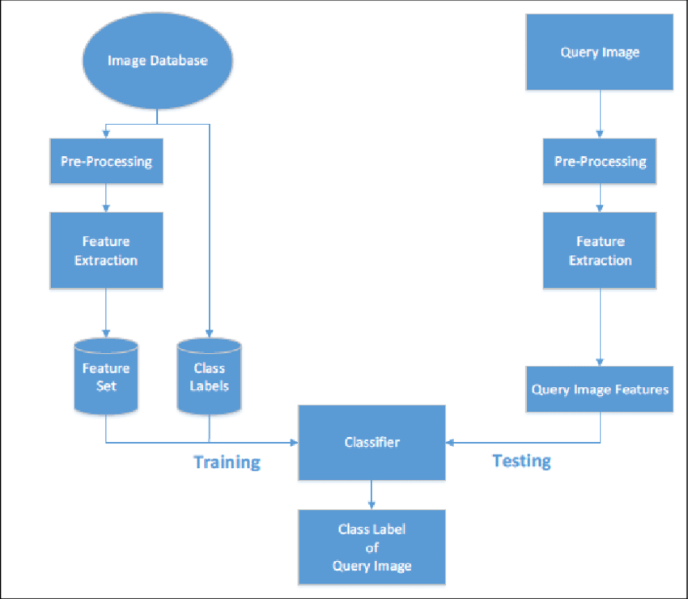

**Proposed Architecture: Image Classification Using Convolutional Neural Networks**

1. **Problem Statement:**

Develop an image classification system using Convolutional Neural Networks (CNNs) to accurately categorize images into predefined classes or labels. The project will be implemented in Python.

2. **Architecture Overview:**

- **Data Collection and Preprocessing:**

- Gather a labeled dataset of images relevant to the application domain (e.g., CIFAR-10, ImageNet, or a domain-specific dataset).

- Preprocess the dataset, including resizing images to a uniform size, normalizing pixel values, and performing data augmentation (if needed) to increase dataset diversity.

- **Model Architecture Design:**

- Experiment with various CNN architectures, such as AlexNet, VGG, ResNet, Inception, EfficientNet, or custom architectures tailored to the project's requirements.

- Consider the following components in the model architecture:

- Convolutional layers with different filter sizes.

- Activation functions (e.g., ReLU).

- Pooling layers (e.g., MaxPooling or AveragePooling).

- Batch normalization for faster convergence.

- Dropout layers to prevent overfitting.

- Optimize the model architecture for the specific image classification task.

- **Model Training:**

- Split the dataset into training, validation, and test sets.

- Train the CNN model on the training data using an appropriate loss function (e.g., categorical cross-entropy) and optimization algorithm (e.g., Adam or SGD).

- Monitor training metrics (accuracy, loss) and use early stopping if necessary to prevent overfitting.

- Save the trained model weights for future use.

- **Model Evaluation:**

- Evaluate the trained model on a separate validation dataset to assess its accuracy, precision, recall, F1-score, and confusion matrix.

- Fine-tune hyperparameters, if needed, to improve model performance.

- Visualize evaluation results and provide insights into the model's behavior.

- **Model Deployment:**

- Develop a user-friendly interface for model deployment. Options include:

- A web application using Flask or Django.

- A REST API using Flask-RESTful or FastAPI.

- Allow users to upload images for classification.

- Implement error handling and feedback mechanisms for user interactions.

- **Documentation:**

- Create comprehensive project documentation, including:

- Project objectives and problem statement.

- Data collection and preprocessing steps.

- Details of the chosen CNN architecture.

- Model training and evaluation procedures.

- Deployment instructions.

- User documentation for the deployed system.

- Code documentation and comments for clarity.

- **Testing and Validation:**

- Perform unit testing on code components to ensure functionality.

- Conduct thorough testing and validation of the entire system.

- Address any potential issues or bugs.

3. **Tools and Libraries:**

- Python for coding and scripting.

- TensorFlow or PyTorch for building and training CNN models.

- Scikit-learn for evaluation metrics and data preprocessing.

- Matplotlib or Seaborn for data visualization.

- Web development frameworks (Flask, Django, FastAPI) for model deployment.

- Jupyter Notebook or IDEs like Visual Studio Code for development.

4. **Project Timeline:**

- Week 1-2: Data collection and preprocessing.

- Week 3-4: Model architecture design and implementation.

- Week 5-6: Model training and evaluation.

- Week 7-8: Model deployment and interface development.

- Week 9-10: Documentation, testing, and final adjustments.

5. **Deliverables:**

- Trained CNN model.

- Deployed image classification system with a user interface.

- Comprehensive project documentation.

- Presentation summarizing the project and its outcomes.

6. **Future Enhancements:**

- Transfer learning with pre-trained models.

- Integration with cloud services for scalability.

- Real-time image classification using video streams.

- Exploring model interpretability techniques.

- Handling multi-class and multi-label classification scenarios.

7. **Conclusion:**

This proposed architecture outlines the key components and steps for developing an image classification project using CNNs in Python. The project aims to create a robust and user-friendly system capable of accurately classifying images in a chosen domain, with potential for future enhancements and applications.

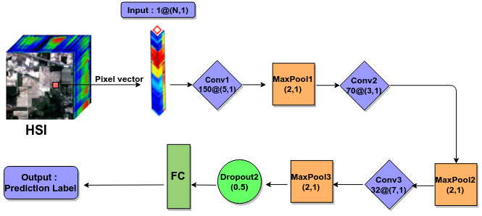

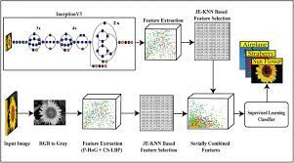

**Project Title: Image Classification Using Convolutional Neural Networks**

1. **Modules:**

a. **Data Collection and Preprocessing:**

- Module Purpose: Collect and preprocess the dataset for training and evaluation.

- Submodules:

- Data collection: Retrieve a labeled image dataset suitable for the task.

- Data preprocessing: Resize, normalize, and augment images to prepare them for training.

b. **Model Architecture Design:**

- Module Purpose: Define the CNN architecture for image classification.

- Submodules:

- Architecture selection: Choose a suitable CNN architecture (e.g., ResNet, VGG, Inception, or custom).

- Layer definition: Configure the layers, activation functions, pooling, and dropout.

c. **Model Training and Evaluation:**

- Module Purpose: Train and evaluate the CNN model.

- Submodules:

- Dataset splitting: Split data into training, validation, and test sets.

- Model training: Train the CNN using training data.

- Model evaluation: Assess model performance using validation and test datasets.

d. **Model Deployment:**

- Module Purpose: Deploy the trained model for real-world use.

- Submodules:

- User interface: Create a user-friendly interface for uploading and classifying images.

- Error handling: Implement error detection and feedback mechanisms.

e. **Documentation and Reporting:**

- Module Purpose: Document the project and results.

- Submodules:

- Project documentation: Create comprehensive documentation for the project.

- User documentation: Provide user guidelines for the deployed system.

- Presentation: Prepare a presentation summarizing the project.

2. **Design:**

- **Data Collection and Preprocessing:**

- Data Collection:

- Collect a diverse dataset of images with class labels.

- Examples: CIFAR-10, ImageNet, or a domain-specific dataset.

- Data Preprocessing:

- Resize images to a uniform size (e.g., 224x224 pixels).

- Normalize pixel values to a range of [0, 1].

- Apply data augmentation techniques (e.g., rotation, flipping) to increase dataset size.

- **Model Architecture Design:**

- Architecture Selection:

- Choose a pre-defined CNN architecture or design a custom one.

- Consider the number of layers, filter sizes, activation functions, and pooling layers.

- Layer Definition:

- Define convolutional layers with ReLU activation.

- Utilize max-pooling layers for downsampling.

- Implement dropout layers for regularization.

- **Model Training and Evaluation:**

- Dataset Splitting:

- Split the dataset into training (70%), validation (15%), and test (15%) sets.

- Model Training:

- Train the CNN using the training dataset.

- Use categorical cross-entropy loss and the Adam optimizer.

- Model Evaluation:

- Assess accuracy, precision, recall, F1-score, and confusion matrix on the validation and test sets.

- **Model Deployment:**

- User Interface:

- Develop a web-based interface using Flask or Django for image uploading and classification.

- Error Handling:

- Implement error messages for invalid inputs or classification failures.

- **Documentation and Reporting:**

- Project Documentation:

- Create detailed documentation covering project objectives, data, architecture, training, and deployment.

- User Documentation:

- Prepare user guidelines for interacting with the deployed image classification system.

- Presentation:

- Summarize the project, methodology, results, and future enhancements in a presentation.

3. **Algorithm:**

1. **Data Collection and Preprocessing:**

- Collect labeled image dataset.

- Resize images to a fixed size.

- Normalize pixel values.

- Apply data augmentation techniques.

2. **Model Architecture Design:**

- Choose or design a CNN architecture.

- Configure the layers, activation functions, and pooling.

- Define dropout layers for regularization.

3. **Model Training and Evaluation:**

- Split the dataset into training, validation, and test sets.

- Train the CNN using training data.

- Monitor loss and accuracy during training.

- Evaluate the model on the validation and test datasets.

4. **Model Deployment:**

- Develop a web-based user interface for image classification.

- Implement error handling for user interactions.

5. **Documentation and Reporting:**

- Create comprehensive project documentation.

- Prepare user guidelines for the deployed system.

- Develop a presentation summarizing the project and results.

4. **References:**

- [TensorFlow Documentation](https://www.tensorflow.org/guide)

- [Keras Documentation](https://keras.io/)

- [Python OpenCV Documentation](https://docs.opencv.org/master/)

- [Flask Web Framework](https://flask.palletsprojects.com/)

- [Django Web Framework](https://www.djangoproject.com/)

- [Scikit-learn Documentation](https://scikit-learn.org/stable/documentation.html)